PABSON, Kathmandu
MID TERM EXAM-2080

Subject: Compulsory Mathematics Full Marks: 75
Class: 10 Time: 3 hours.
Candidates are required to write their answers according to the instructions given.

Attempt all questions.

1. 64 students in grade X are preparing for SEE in a school. Among them, 28 students are taking math additional class, some of them are taking science class,12 students taking math and science both class and 25% of students are not taking any additional classes.
a) If M and S be the set of students who want to take math and science additional class respectively, write cardinality notation to represent who like to take only one subject. [1]
b) Represent above information in Venn diagram. [1]
c) How many students are taking science additional class? Calculate. [3]
d) If the School collects Rs.500 per person monthly from the additional class’s students, how much amount will be collected in a month? [1]
2. Sulakshyana is planning to build a new house at Kathmandu. For this purpose, she wants to borrow Rs 10,00,000 loan for two years. The interest rates home loans of two financial institutions are as follows.
Provident Fund: 9% annual interest.
Rastriya Banijya Bank: 8% semi-annual interest.
a) Find the compound amount of ‘T’ years of Rs ‘P’ at ‘R’% quarterly interest rates. [1]
b) From which institution does she borrow the loan? Give reason with your calculation. [3]
c) If Sulakshyana will manage Rs.12,00,000 to clear the debt after 2 years, is it sufficient amount ? [1]

3. The population of a town increases every year by 10%. At the end of 2078, the population of the town was 30,000.
a) If ‘P’ be the initial population, ‘R’ be the growth rate and ‘T’ be time and what does $P{\left(1+\frac{R}{100}\right)}^{T}-P$ denote for? [1]
b) What would be the population of town at end of 2080 B.S.?
[1]
c) If the population of 30,000 at end of 2078 includes 5800 population by in-migrants, find the population of end of 2076. [2]
4. Sagar purchased a car for Rs. 90,00,000 and land for Rs. 2,10,00,000. For 2 years, the price of the car has been decreasing at a compound rate of 5% per annum, while the price of land has been increasing at a certain compound rate.
a) Write the formula to find out the compound depreciation. [1]
b) What will be the price of a car after two years? Calculate. [1]
c) After 2 years the total value of car and land is Rs.3,73,62,900, what is the increase compound rate in the price of land? Calculate. [2]
5. Ansuna Nepal is planning to travel USA for CA course. She exchanged US $ 4,000 for her abroad study. The buying and selling rate of 1 US$ of Nepal Rastra Bank are Rs. 130.94 and Rs. 131.5 respectively.
a) At what rate did she buy US dollar? [1]
b) Find the exchange rate of Nepali currency after devaluation by 10%. [2]
c) If she cancelled her travel and again exchanged US dollars to Nepali rupee, how much did she gain or loss? [2]
6. There is a pillar with the base 6ft$×$6ft and height 8ft. A pyramid of height 4ft is placed on the top of the pillar.
a) Find the formula to find area of triangular faces. [1]
b) Find the slant height of pyramid. [1]
c) Find the cost of painting on pillar and pyramid of its’ faces at the rate of Rs.95 per square feet$.$ [2]
7. A birthday hat with conical shape is designed with circumference of base 44 cm and vertical height of 24 cm. A piece of elastic is attached along its diameter.
a) How long is the elastic? [1]
b) Find area of paper to make hat. [2]
c) How much cubic centimeters of air does it hold? [2]
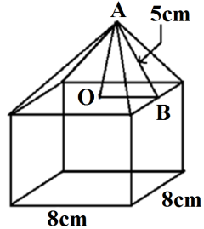
8. In the given solid the upper part is a pyramid has a slant height 5cm and lower part is a prism of a side 8cm. If the volume of the solid is 448 cm³,

a) Find the volume of the prism. [2]
b) Find the height of solid. [2]

9. Agrima Dhungel is working in a company and her saving of last five months are given below.
Baishakh | Jestha | Ashad | Shrawan | Bhadra
Rs. 200 | Rs 400 | Rs 800 | Rs 1600 | Rs 3200
a) Which sequence does the saving of Agrima denote? [1]
b) If her saving continues in same order in the coming months, what will be her total saving till the month of Mangsir month? [2]
c) Is it possible to save a total of Rs. 1,00,000 upto Poush? Write with reason. [2]
10. a) If a^{P}=a^{X}, then express $x$ in terms of m, n and p.[1]
b) If $x^{a}=y^{b}=z^{c}$and $y^{3}=xz,$ prove that $\frac{3}{b}=\frac{1}{a}+\frac{1}{c}$ [2]
c) Solve: $4^{x}-6×2^{x+1}+32=0$ [3]
11. a) What value of y makes the expressions $\frac{x^{2}y}{2x-y}$ undefined? [1]
b) Simplify: $\frac{1}{x-1}-\frac{x}{x^{2}-1}-\frac{x^{2}}{x^{4}-1}$ [3]
12. In the figure alongside, parallelogram ABCD and $∆$DCE are on the same base DC and between same parallel lines CD and AE.
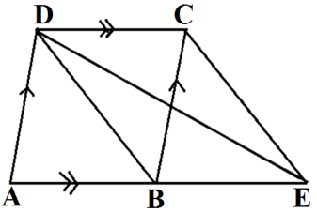
a) What is the relation between $∆DCE and ∆DCB$ ? [1]
b) If the area of $∆$ DCB is 15cm², find the area of parallelogram ABCD. [1]
c) Prove that area of parallelogram is twice the triangle on the same base and between same parallel lines. [2]
13. O is the center of a circle. Central angle $∡ MON$ and inscribe angle $∡MAN$are standing on the same arc MN.
a) What is the relation between the central angle $∡ MON$and inscribed angle $∡MAN$ ? [1]
b) If inscribed angle and central angle on the MN arc are (7x)⁰ and (5x+18)⁰, find the actual value of $∡ MON$. [2]
c) Verify experimentally the relationship between the central angle $∡ MON$ and inscribed angle $∡MAN.$(At least two circles with radii more than 3 cm are necessary) [2]
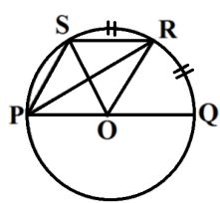
14. In the given figure, O is the center of the circle, PQ the diameter and arc QR=arc RS.

a) Prove that: $PS ∥OR$. [2]
b) If the area of $∆$POR is 5 cm², find the area $∆$SOR. [1]
15. A pillar AB is fixed at the center of circular pond. The circumference of pond is 88 m. A bird looks a man standing on the bank of pond and finds the angle ${60}^{0}.$
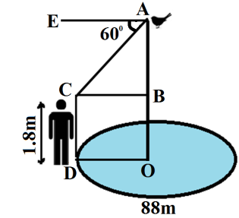
a) What is called $∡CAE$ ? [1]
b) Find the radius of the pond. [1]
c) What is the height of pole above the water level? [1]
d) If the bird changes its place 12.04 meter below top of pillar, how many more or less will angle of elevation be while observing the bird? [2]
16. The lower quartile of data given below is 25.
Marks | 0-10 | 10-20 | 20-30 | 30-40 | 40-50 | 50 and above
No of students | 9 | 11 | $$x$$ | 20 | 30 | 16
a) What is determined by using formula . [1]
b) What is lower quartile class of above data? [1]
c) Find the value of $x$. [2]
d) If students’ scores less than 40 marks are marked as non- graded, find percentages of non-graded students. [2]

